David Allen

G00375372

Week 7

**Contains**: Assignment 5B – Pre-requisites od Sprint 1,   
Execution/Demo/Retrospective and Sprint 2 planning Brief

**Team Blade Runner**:

**Scrum Master** - Ion Cirnici G00374920

**Product Owner** – Luke Byrne G00373744

**Software Engineer** – David Allen G00375372

**Software Engineer** – Sam Brownless G00260547

**Product Tester** – Ammad Aslam G00365389

Project Management



Contents

Sprint 1 - Progress/End of sprint 2

Meetings 2

Sprint backlog refinement 2

Testing 3

Sprint Progress 4

GitHub 6

Sprint Demo 6

Sprint Review 7

Sprint Retrospective 7

Sprint 2 10

Sprint/Release Planning 10

Sprint Goals 10

Sprint Plan 10

Confidence Vote 11

Scrum/Task Board 11

Jira/Additional Info 12

Release/Product Burndown Chart 12

Sprint Execution 12

# Sprint 1 - Progress/End of sprint

## Meetings

Meetings of this week, second part of sprint 1:

**Monday 24th Feb – meeting**

Unfortunately, majority of the team couldn’t get together due to members being assigned to another project. (Networking test Wednesday). The team knew what stories were being worked on and what need to be done based on the sprint plan.

**Wednesday 26th Feb 9 – Scrum/meeting**

One member missing, but scrum proceeded. Members updated the progress with their tasks and new tasks were allocated.

**Thursday 27th Feb – meeting**

Sprint one was briefly reviewed. Stories completed and what needed to be done before the end of sprint. Final tasks given out to keep within schedule.

**Friday 28th Feb – Sprint review/demo + Sprint 2 planning**

The whole team gathered to present a sprint demo to the PO. Sprint 1 was reviewed, and we looked back on what went wrong/right in the sprint, so we could make improvements for sprint 2. Sprint 2 was planned, and all user stories were broken down into task.

## Sprint backlog refinement

During our meeting we reached agreement that our velocity had been accurately dictated for sprint one as we had managed to release majority of our tasks that had been set out for the sprint. The main contributor for the missing task, was a networking test that made the project get side-lined for two days. These sorts of events should have originally been taken into consideration when we did the original sprint plan. But looking towards sprint 2, there are no more external issues that should delay us. During testing towards the end of the sprint we decided that error handling for our contact form was an issue that was under sized, therefore should be developed during the second sprint.

Due to testing issues the error handling will be taken care of in the next sprint as we feel that it won’t have an impact on our velocity.

## Testing

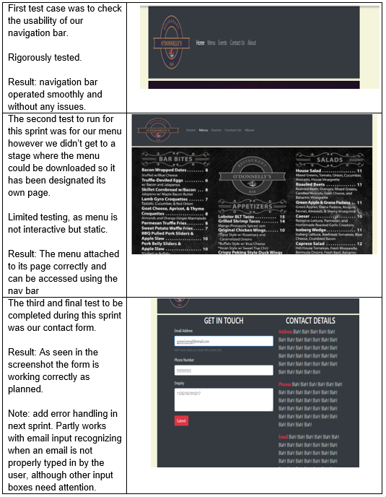Our testing ended up being a bit of an issue for the team as our tester was not very experienced with the software, we had available to us. Due to this issue we manually carried out tests using test cases for the sections of the website that we had developed during this sprint. This was handled by other members who had not taken part in that task, so the results would be honest.

Each test was carried out by a member within the team. Checking functionality, usability and the interface. Making sure each task worked as mandated by its purpose.

## Sprint Progress

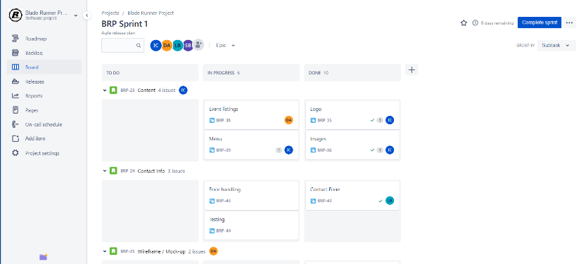Sprint progress/Scrum board.

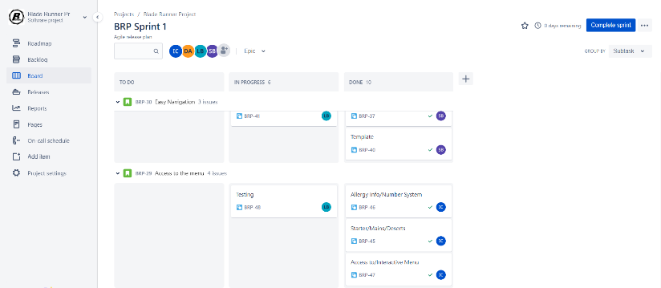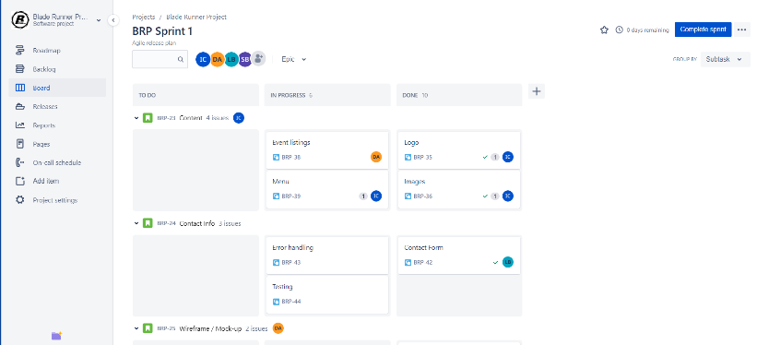

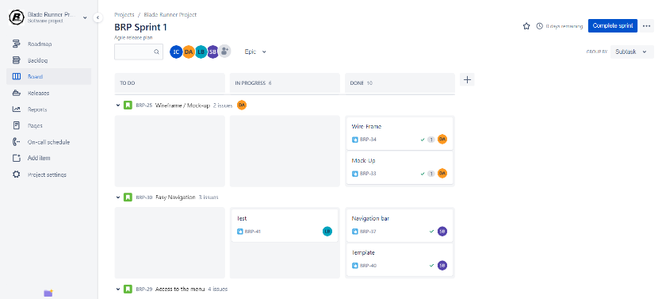

Jira was used to keep our sprint progress monitored. It allowed members to update the scrum board to keep all members on the same page with progress and what needed to be done.

Unfortunately, part of our retrospective is that not all Jira progression was updated in a timely manner and when you move the tasks around, they update to that current date and time, which effected our burndown chart.

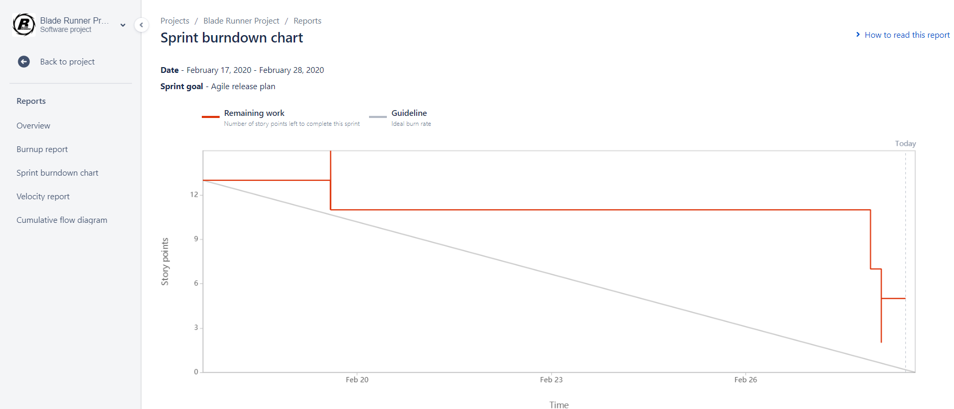As seen above, when tasks are moved the progress is recorded. But the data was not correct and make this chart a big fat lie as it indicates all tasks were completed last minute.

Although part of sprint 1 we were having problems with the burndown chart and how it was implemented on Jira, so we manually added a burndown chart we kept for our own records in our meetings

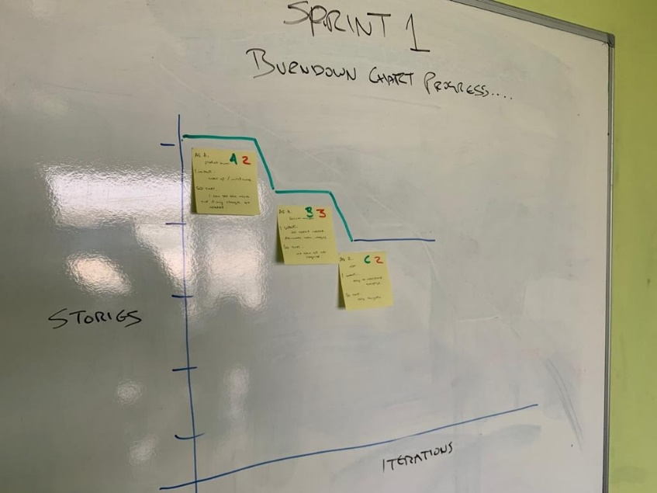

Sprint 1 progress for the end of the first week. Shows some progress and more tasks to be done.

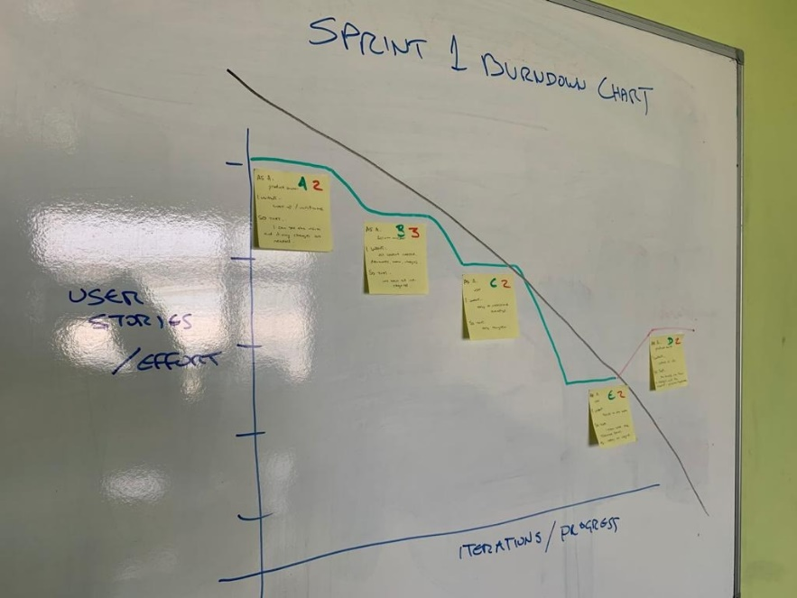

The completed burndown chart for sprint 1. We had good progression, but you can see at the end where we developed difficulties.

For a more detailed information on our progression, please check our OneNote.

## GitHub

GitHub is steadily updated buy each member.

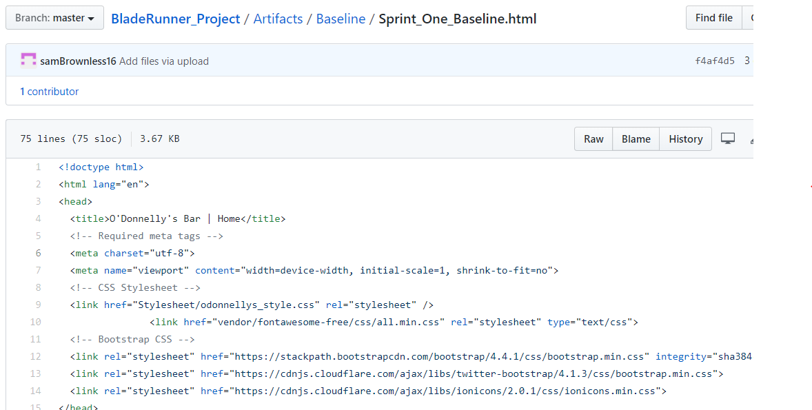A baseline was set for the first sprint, so that we had a backup of the code in case something went wrong.

It meant we wouldn’t have to completely start over again and had a point of reference.

All GitHub activities are notified to each member and it’s been recommended for members to review code uploaded and give honest feedback/ opinions in form of code inspections.

## Sprint Demo

The team held a sprint demo on the last day of the sprint. We started with the sprint demo, showing the PO what we had worked on, what had been completed/not completed and any issues that came up.

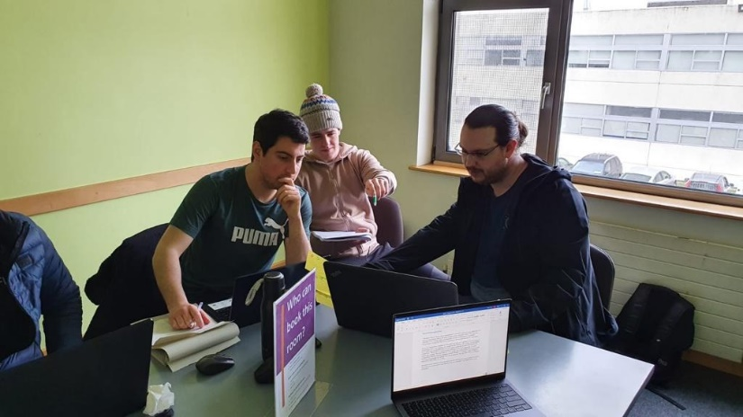

The sprint demo was recorded and can be viewed at <https://youtu.be/vQ7LqoC9NUg>.

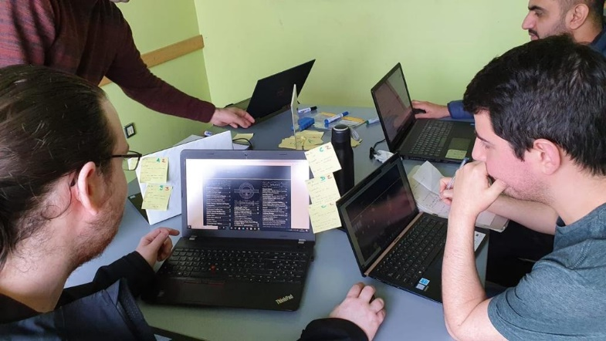The team discussed the project with the PO and we answered any questions that he had.

## Sprint Review

After the Sprint demo, we reviewed how the sprint went. Overall, it went well, considering it was a completely new process. It had its ups and downs, but ultimately the team succeeded in their requirements. As per the sprint plan, the tasks were mostly achieved and kept within scope. Although one task was not completed due to issues in testing and it didn’t help that members were distracted by other projects. It was argued that these issues should have been foreseen and additional time should have been added to the sprint plan/schedule to allow for any issues that may occur.

It was a learning curve for all members but should set us up for a better sprint 2. With experience now under our belts and prepare us for a better velocity for the next sprint.

## Sprint Retrospective

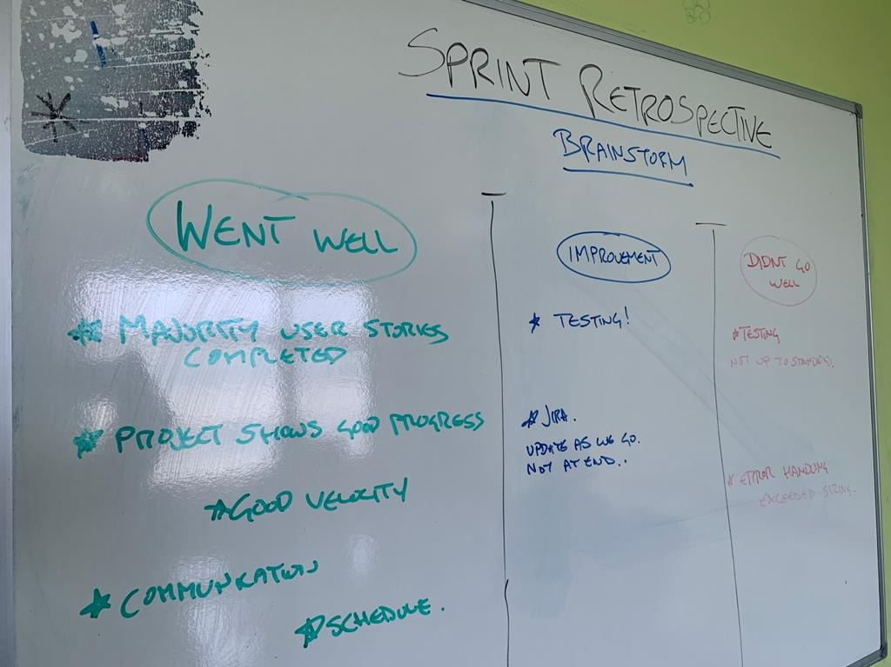

During our retrospective meeting and brainstorm we were all in agreeance that the product is progressing well in most aspects. Our velocity we felt had been set correctly as most of our tasks were completed by the end of the sprint, except the error handling for our contact form. We felt that our communication throughout the sprint was good, our work output was on target. The main issue we came across was during testing this due to our lack of experience with the software. However, we still managed to complete a basic testing by manually going through the website. Our improvements for the next sprint will be to improve testing and make better use of JIRA.

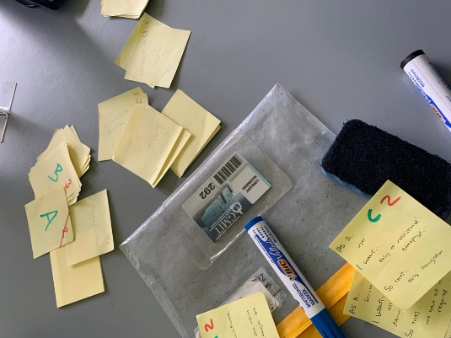

We anonymously put our thoughts down/collected comments from the entire development team on post its, to check and see if there were any issues anyone was afraid to bring up to the team. Testing issues were mentioned and allowed us to reassess the testing situation with no blame associated.

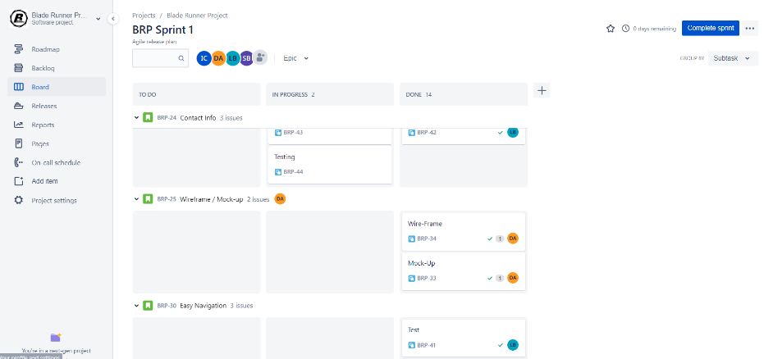

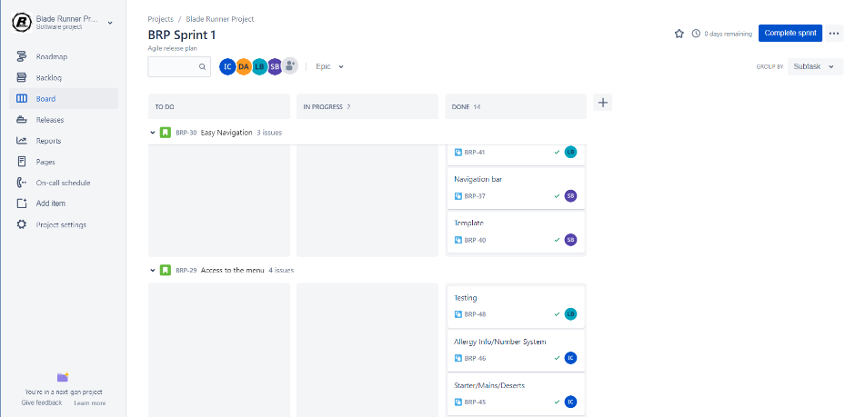

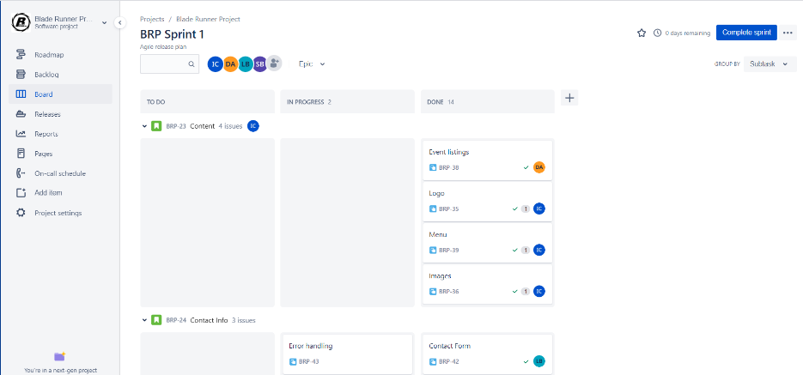



We originally drew up the scrum board on the whiteboard believing that face to face interaction was better.

But Jira allowed us to keep each other up to date on all situations. As you can see in the images, all but one task was completed. Its shows that we went through the processes of each task and they were not allowed to be completed until they defined our definitions of done.

As in our retrospective, Jira was not updated as promised within the team and should have been down more regularly. Therefore, the burndown chart on Jira is skewed.

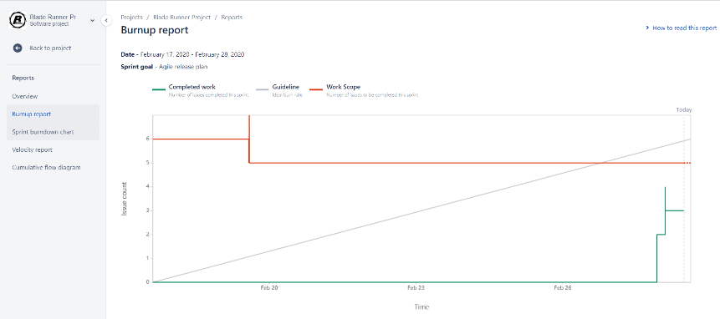

But we were having issues with Jira from the beginning as it was a new software for the team, and we did record the burn down chart information manually as well.

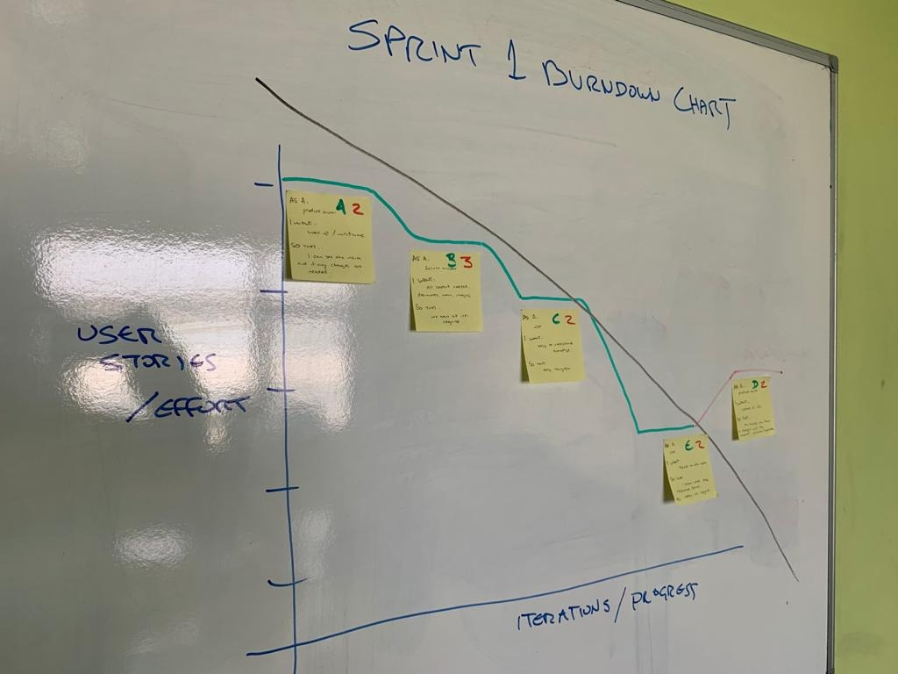

The burndown chart for sprint 1 shows how we were working well and to schedule but at the end we ran into issues we couldn’t address, and it made the chart go negative.

# Sprint 2

The project duration consists of 2 sprints, each sprint is 2 weeks long.

* Sprint 1: Monday 17th February – Friday 28th February

Completed.

* Sprint 2: Monday 2nd March – Friday 13th march

Starting.

## Sprint/Release Planning

With sprint 1 completed, it was time to plan and prepare for sprint 2. We started with prioritizing the tasks that needed to be completed and created a sprint plan and scrum board. The scrum board contained all user stories and had them broken down into smaller tasks for all members to complete.

## Sprint Goals

Our goal for this second sprint of the project is to output as close to a finished project as possible. We also aim to improve our testing and complete a task which has been brought over from our previous sprint. By making better use of Jira in this next sprint we aim to increase our team’s efficiency.

## Sprint Plan

The team velocity worked well in sprint 1, so we believe that our plan was still valid and sized well. The only difference was the addition of the uncompleted tasks from sprint 1 into the 2nd sprint. It was only one task left out of the user story to be completed, so was resized to half a point. Meaning we should be able to add it into the new sprint without any complications and it should still be within our scope.

## Confidence Vote

The fist of five worked well last time, so it was used this time. No complications, all members had a positive view on sprint 2 and agreed that there should be no issues. All members were more confident after the initial sprint as we now had a better understanding and could use the experience gained from sprint 1 to overcome any problems along the way.

## Scrum/Task Board

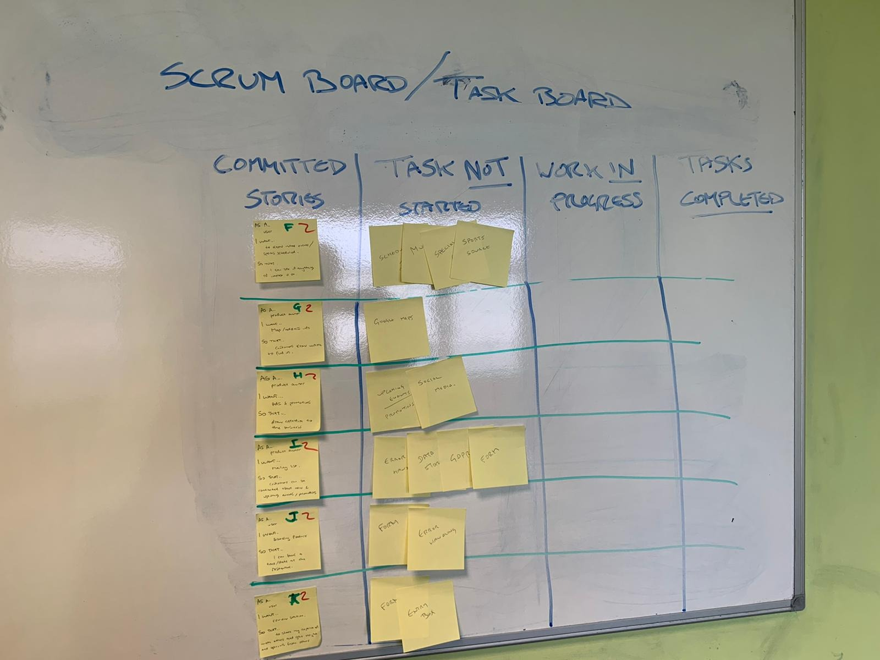

All user stories committed to sprint 2, were broken down into multiple smaller tasks. Each member has the option to take tasks and update the board as we proceed.

## Jira/Additional Info

All information will be added to Jira. Jira was a learning curve, but we learnt a lot in the first sprint. Including a lot of mistakes, that will help avoid repeating them again.

## Release/Product Burndown Chart

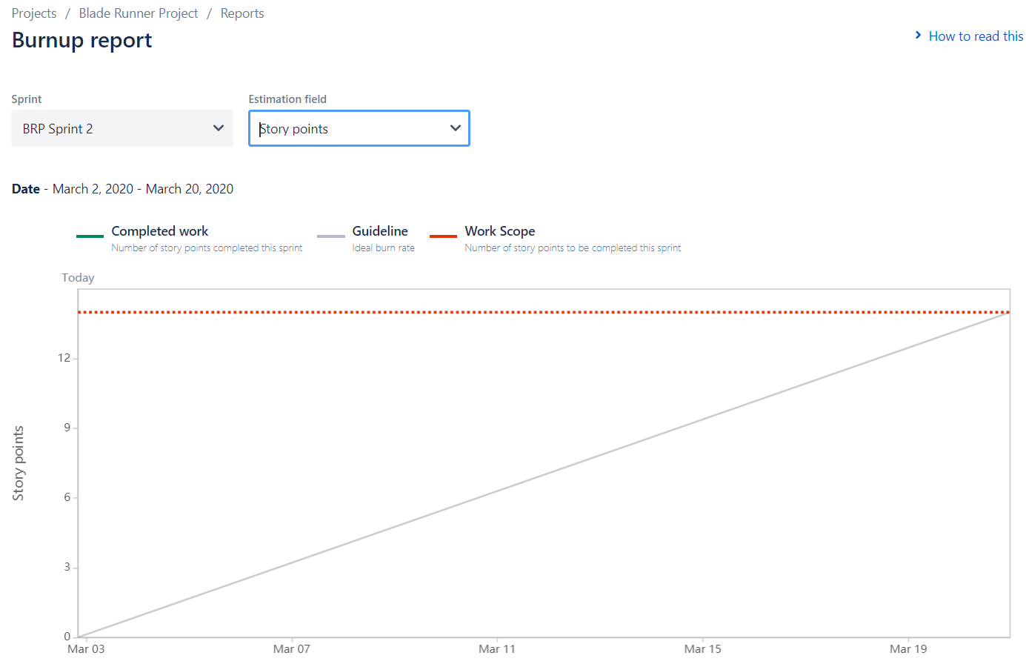

The initial burndown chart for sprint 2. Not a lot of data now, but that’s due to the sprint only just beginning and the tasks are only just being selected by each member.

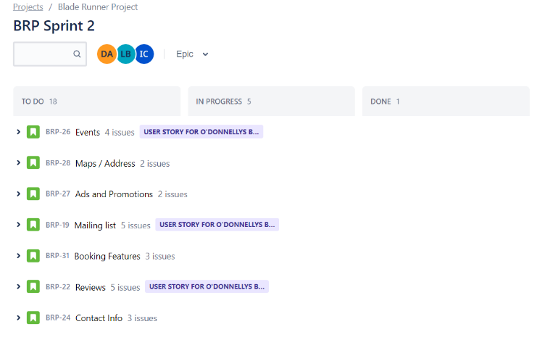All user stories are ready to go. Jira is a well-developed program. Once sprint 1 was completed it noticed that not all tasks were completed and transferred them into sprint 2.

Sprint 2 is ready to go, and tasks are currently being decided on by each member. Jira will be amended accurately as each task is taken/completed as discussed in the sprint retrospective.

## Sprint Execution

Baselined the code to GitHub And Sprint 2 begins.